Google Tag Manager

# Introduction

Websites often contain snippets of JavaScript code called “tags” that collect information like behavior data, remarketing data, ecommerce, and more. This makes it easy to send information to products like Google Analytics.

But sometimes, a site can have so many tags, that it becomes cluttered and difficult to manage.

Tagging a site also requires some knowledge of coding, and embedded tags can reduce the speed of your site, or even crash it, if they’re not implemented properly. That’s where Google Tag Manager can help.

With Tag Manager, you no longer have to add tags manually to a website. Instead, you can use Tag Manager to create Google Analytics, AdWords, or any third-party tags, and specify when they should fire. This simplifies and speeds up the process of tag deployment, and can really streamline tag loading for faster website performance. It can also help you manage different versions of your tags, making you less reliant on developers for changes.

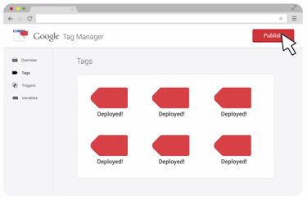

#### Course Overview

This course will walk you through the basics of Tag Manager including developing a measurement plan and a tag management strategy. We’ll discuss how to deploy tags and triggers, and show you how to set up variables that can be reused across your site.

We’ll also discuss how you can use the Data Layer, along with variables and events, to pass information from your website into other tools for marketing and analysis.

Finally, we’ll use Tag Manager to set up advertising and remarketing tags. While the course examples will focus on Tag Manager for desktop, the same principles can apply for mobile apps, as well.

We’ll use tagging examples from *The Great Outdoors* - the world’s leading fictitious retailer of outdoor camping and hiking equipment, sporting goods, and clothing. In addition to their online and retail stores, *The Great Outdoors* recently launched a new travel website called “The Great Outdoors Travel Adventures.”

This is a site where customers can research and plan travel, as well as book airline tickets and hotel accommodations. *The Great Outdoors* will need your help using Google Tag Manager to add tags to their *Travel Adventures* website, and collect data to better understand customer behavior.

We’re really excited you’re able to join us for this latest Analytics Academy course and we look forward to your participation!